The 2026 China Post-Graduate Mathematical Contest in Modeling, Problem H
Cooperative Optimization of UAV Transport and Communication Under Mountain Flood Disaster Scenarios

Background
Mountain flood disasters are typically characterized by high suddenness, scattered affected areas, and simultaneous damage to road, power supply and communication facilities. Sustained intense rainfall may trigger flash floods, landslides, and road collapses, rapidly cutting off reliable ground access to some settlements. In the early stages of disaster response, drinking water, emergency food, medical supplies, and hygiene supplies must be delivered as quickly as possible, yet conventional vehicles often cannot reach areas with rugged terrain and severely damaged roads in time. Unmanned Aerial Vehicles (UAVs) are less affected by ground road conditions and can therefore provide an important supplementary means of emergency transport.
In July 2026, due to the persistent heavy rainfall triggered by Typhoon Maysak, a severe flood disaster struck Zhenlong Township, Hengzhou City, located in Guangxi, China. On-site reports by Xinhua News Agency correspondents in Zhenlong Township showed that floods, rockfalls, and road collapses blocked access from multiple directions, temporarily leaving the worst-affected area without transport access and with disrupted communications. A subsequent report in Xinhua Daily Telegraph stated that roads, electricity, and network connections had been cut off in Zhenlong Township, stranding approximately 8000 people across the township. During the rescue operation, food, drinking water, and medicines had to be delivered to the affected area on foot or by air. Large UAVs also transported materials for emergency power repairs, while temporary communications equipment and emergency power supplies were used to gradually restore contact with the affected area. This real-world scenario demonstrates that emergency supply transport and communications support often need to be coordinated under conditions of blocked roads, limited energy, and incomplete information.
In actual rescue operations, successful supply delivery depends not only on whether a UAV can reach the target area, but also on payload, horizontal flight distance, ascent and descent heights, terrain clearance along the route, energy reserves, mission deadlines, and equipment turnaround. Meanwhile, transport UAVs must maintain command, telemetry, and handover confirmation links throughout ascent, cruise, descent, and supply handover. When fixed communications infrastructure is damaged, or terrain obstruction prevents a ground gateway from covering the entire mission interval, airborne relay UAVs must provide temporary communications support at suitable locations and times. Supply delivery during flood disasters in mountainous areas therefore requires coordinated consideration of UAV transport, communications support, and equipment resources.

Standard Test Scenario
The problem uses Zhenlong Township and the surrounding mountainous area as its geographical setting and defines a standard test scenario (the actual scenario may differ slightly). The attachments provide 1 temporary dispatch center, 15 service areas, and 80 indivisible cargo containers. Three transport UAV models are specified, with a total of 8 individual transport UAVs, together with information on their shared battery packs, Digital Elevation Model (DEM) data, relay UAVs, replaceable energy modules, and wireless link parameters. Spatial coordinates and open geographical data are adopted to describe the test scenarios, while the parameters of requirements, time limits, equipment, and resources shall be subject to the given values specified in the attachments.

Problem Description
Based on the aforementioned scenarios, this problem investigates the synergistic relationship among UAV material transportation, communication relay and rescue resource allocation, with a focus on addressing issues including the organization of transportation tasks, the matching of communication support, and rational allocation of limited resources.

Problem 1: Single-Destination Round-Trip Transport Capacity and Cargo Container Batching Scheme
Without considering the scheduling of individual UAVs or shared batteries, this problem investigates transportation capacity and a cargo container batching scheme under the direct round-trip scenario in a single service area. Each sortie follows the direct round-trip route O01→Si→O01 and serves only one service area, where $O01$ denotes the temporary dispatch center and Si denotes the $i-th$ service area ($i=1,2,…,15$). A service area may be served in batches by multiple sorties, but cargo containers for different service areas must not be combined into one batch. Using the node coordinates, 30 m DEM, UAV model parameters, and cargo container data provided in the attachments, complete the following tasks:
Calculate the maximum safe payload of three types of UAVs when performing single-destination round-trip tasks in different service areas.
- Determine a cargo container batching plan for each service area under the constraints that cargo containers are indivisible, each container can be assigned only once, and requirements including payload capacity, loading volume and safety energy reserve for return flight are satisfied.
- Optimize the batching plan to deliver all cargo containers while jointly considering the number of round-trip sorties, total transport energy consumption, and cumulative operating time. Explain the trade-offs or priorities among these objectives.
- Also discuss how changes in the return-to-base safety reserve affect the maximum safe payload of each UAV model and the resulting cargo container batching plans.

Problem 2: Multi-Destination, Multi-Sortie Transport Scheduling for Heterogeneous UAVs
Without considering communication support, this problem investigates multi-destination, multi-sortie transport scheduling for heterogeneous transport UAVs. Each transport sortie may visit one or more service areas and must return to O01 after completing its deliveries. Jointly determine cargo container batches, the visiting order of service areas, the transport UAV model, the individual UAV assigned, the shared battery assigned, and the start time of each sortie, subject to constraints on cargo container indivisibility, payload mass and loading volume, return-to-base safety reserves, the numbers of UAVs and shared batteries, charging and turnaround, and delivery deadlines. Medical supplies must meet the desired delivery times specified in the attachments, and cargo containers required in the initial delivery must meet the initial-delivery deadlines. The desired delivery times for other supplies are used to assess delivery timeliness. On the basis of these requirements, the following tasks are completed:
- Optimize the schedule by jointly considering delivery timeliness, the completion time of all missions, transport energy consumption, and the number of sorties, and explain the trade-offs among these objectives. (The completion time of all missions is the latest time at which any transport UAV completes its final sortie and returns to O01.)
- Provide the transport routes, sortie schedule, delivery time of each cargo container, and UAV and battery resource usage, and verify the resource feasibility of the plan.

Problem 3: Joint Scheduling Scheme for Transport and Relay Under Communication Constraints
With communication support taken into account, this problem investigates the joint scheduling of transport UAVs and relay UAVs. Transport UAVs must maintain continuous communications during ascent, cruise, descent, and supply delivery. When a direct link to the fixed gateway is unavailable, an airborne relay UAV may provide communications support. Communication status shall be determined according to Appendix 3 and its corresponding supporting parameters. Jointly determine cargo container batches and visiting orders, transport UAV and shared battery assignments, the start time of each sortie, and the hovering locations, flight altitudes, service intervals, and energy module assignments of relay UAVs, subject to constraints on cargo container deadlines, payload and energy, continuous communications, and resource availability. Relay hovering locations must lie within the coverage of the provided DEM, and hovering height above ground must not exceed the upper limit specified in the attachments. On the basis of these requirements, the following tasks are completed:
- Optimize the joint schedule by jointly considering supply delivery timeliness, the completion time of the joint missions, total transport and relay energy consumption, and the numbers of sorties flown by the two types of UAVs, and explain the trade-offs among these objectives. (The completion time of the joint missions is the latest time at which any transport UAV or relay UAV completes its final sortie and returns to O01.)
- Provide the joint transport and relay schedule, and describe cargo container delivery, resource usage, and communications support.

Problem 4: Rescue Mission Partitioning and Resource Allocation Optimization
Considering that post-disaster rescue may require the overall mission to be divided into several relatively independent execution units, it is necessary to investigate the impact of different mission partitioning schemes on resource allocation and to evaluate the resource requirements, redundancy, and allocation shortfalls for independent execution of each partition. On the basis of the joint scheduling scheme obtained from Problem 3, the 15 service areas are divided into two and three mission groups separately. The task partitioning scheme is determined by contestants. Each service area must belong to exactly one mission group, and each group must contain at least one service area. During partitioning, retain the cargo container batches, visiting orders of service areas, transport and relay mission schedules, and communications support relationships established in Problem 3. If a transport sortie involves multiple service areas, those areas must be assigned to the same mission group. Each mission group undertakes only the transport and communications support missions associated with its own service areas. For each group, separately calculate the numbers of transport UAVs, shared batteries, relay UAVs, and relay energy modules required for independent execution. No resources may be transferred between groups during mission execution. On the basis of these requirements, the following tasks are completed:
- Provide the mission partitioning and resource allocation plans for 2 and 3 mission groups, respectively. Compare the plans in terms of the scale of resource allocation, resource redundancy, workload balance between groups, and resource shortfalls relative to the existing inventory, and analyze the characteristics of the two partitioning approaches.
- If the resources required by a partitioning plan exceed the existing inventory, further identify the corresponding resource shortfalls and explain their causes.

Paper and Result Submission Requirements
The paper shall clearly state the assumptions, notations, models and algorithms, data processing procedures, main results and their applicable conditions, and explain the data inheritance relationship between each problem. In addition to the paper, the necessary result files, verification documentation and executable programs shall be submitted in accordance with the attached template. Different solution methods may be used for different problems, but common physical rules, units, identifiers for service areas, cargo containers, UAVs, and other objects, and calculation conventions must remain consistent. Figures and tables shall present key results, including transport routes, scheduling timelines, resource occupancy, communications support, and mission partitions.

Appendix 1. Scenario Data and Attachment Descriptions
Basic Parameter Data:
The basic parameter data are located in "Data/Basic Data for Drone-Based Emergency Supply Transport" and comprise the following 5 files:
(1) "Dispatch Center and Service Areas.xlsx": provides basic information on the temporary dispatch center and the 15 service areas;
(2) "Supply Demand and Delivery Deadlines.xlsx": provides supply demand, cargo container attributes, delivery time requirements, and individual cargo container information for each service area;
(3) "Transport Drone Data.xlsx": provides parameters for transport UAV models and shared batteries;
(4) "Relay Drone Data.xlsx": provides parameters for relay UAVs and their energy modules;
(5) "Communications Link Parameters.xlsx": provides communications link parameters for the fixed gateway, transport UAVs, and relay UAVs.
Geospatial and DEM Data:
The geospatial data are located in the "Data/Zhenlong Township Geospatial Data" directory. For detailed descriptions, see "Zhenlong Township Geospatial Data Description.docx" in that directory. Figure 1 shows the overall spatial relationship between the 30 m DEM and the dispatch nodes.
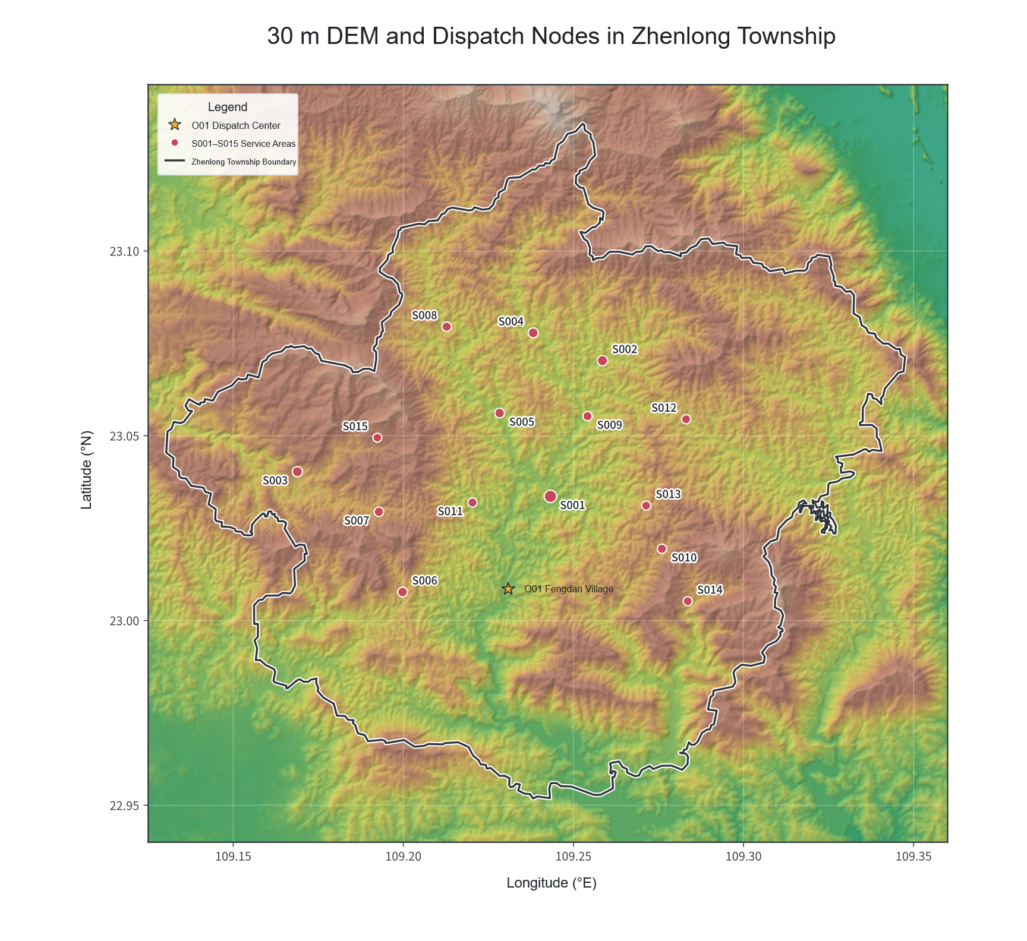
Figure 1. 30 m DEM and Dispatch Nodes

Appendix 2. UAV Time and Energy Calculation Rules
This appendix specifies common calculation conventions for the flight time, energy consumption, return-to-base safety reserves, and energy resource charging and turnaround of transport and relay UAVs. The relevant parameters and units shall be those specified in the accompanying data files.

Transport Flight Segments, Time, and Energy Consumption:
The horizontal straight line between any two mission nodes defines the transport flight segment. The planned cruise altitude is 50 m above the highest ground elevation among the DEM pixels traversed by that segment. Each flight segment is evaluated in three phases: ascent, cruise, and descent. The UAV ascends from the operating height at the starting node to the cruise altitude, completes the horizontal cruise, and then descends to the operating height at the destination node. The operating altitude at O01 equals its ground elevation, while the operating height at a service area is 30 m above its ground elevation. When visiting multiple service areas consecutively, the UAV ascends again from the 30 m operating height after each delivery.
The horizontal cruise distance, ascent height, and descent height are determined from the node locations, DEM, and planned cruise altitude. The equivalent range of UAV model $g$ carrying payload $q$ is:
$$L_{g}(q)=L_{g}^{0}-\left(L_{g}^{0}-L_{g}^{F}\right){\left(\frac{q}{Q_{g}}\right)}^{3/2}, 0≤q≤Q_{g}.$$
Here, $g$ denotes the transport UAV model, and $q$ denotes the current payload (kg); $L_{g}^{0}$ and $L_{g}^{F}$ denote the standard unloaded range and standard fully loaded range of model $g$ , respectively (m); and $Q_{g}$ denotes the maximum cargo mass of model $g$ (kg).
The flight time of a segment is:
$$t_{gij}=\frac{h_{ij}^{+}}{v_{g}^{↑}}+\frac{d_{ij}}{v_{g}^{c}}+\frac{h_{ij}^{-}}{v_{g}^{↓}}$$
Here, $t_{gij}$ is the flight time of model $g$ on the segment from node $i$ to node $j$ (s); $d_{ij}$ is the horizontal cruise distance (m); $h_{ij}^{+}$ and $h_{ij}^{-}$ are the ascent and descent heights, respectively (m); and $v_{g}^{↑}$ , $v_{g}^{c}$ and $v_{g}^{↓}$ are the ascent, cruise, and descent speeds, respectively (m/s).
Transport energy consumption on a flight segment is calculated as the sum of horizontal flight energy consumption and additional ascent energy consumption:
$$E_{gij}(q)=E_{gij}^{hor}(q)+E_{gij}^{up}(q).$$
Here, $E_{gij}(q)$ is the total transport energy consumption on the segment, while $E_{gij}^{hor}(q)$ and $E_{gij}^{up}(q)$ are the horizontal cruise energy consumption and additional ascent energy consumption, respectively (kWh).
A descent energy efficiency of 0 means that no additional descent energy consumption is calculated separately. Each transport sortie must satisfy the return-to-base safety reserve requirement:
EpT=(i,j)∈p​Egij(qpij)≤(1-ρg)Eguse.
Here, $E_{p}^{T}$ is the total transport energy consumption of sortie $p$ (kWh); $q_{pij}$ is the remaining payload of sortie $p$ on segment $i$→$j$ (kg); $ρ_{g}$ is the return-to-base safety reserve ratio of model $g$ ; and $E_{g}^{use}$ is the usable energy of one battery pack for model $g$ (kWh).

Relay UAV Time and Energy Consumption:
A relay UAV departs from O01, reaches its hovering location, establishes the link, and then provides communications service. After its service ends, it returns to O01. Relay UAV flight time is calculated using the ascent, cruise, and descent phases described above. Horizontal cruise energy consumption is calculated from cruise power and cruise time. Additional ascent energy consumption is calculated using the same relationship as above, with mass taken as the planned total takeoff mass. Communications service energy consumption is determined jointly by hovering power and additional communications power. Terrain clearance for the relay UAV's round trip to the hovering location is determined using the flight segment rules above, and the return-to-base safety reserve requirement must be satisfied. Parameters such as fixed preparation time, link establishment time, and sortie turnaround time are provided in "Relay Drone Data.xlsx".

Battery and Energy Module Charging and Turnaround:
Transport UAV shared batteries and relay UAV energy modules are treated as independent energy resources, each with its own state of charge (SOC). The total number of shared batteries specified in the attachments includes both the batteries initially used by individual UAVs and those required as spares for turnaround. Shared batteries for the same UAV model may be scheduled for use by different individual UAVs of that model, but batteries must not be used across different models. All resources have an initial SOC of 100%. The remaining SOC after a mission is calculated from usable energy and actual energy consumption and must not fall below the minimum return battery level. Each resource must be recharged to 100% before being used for another mission.
Both types of energy resources use the same two-stage equivalent charging model. Charging is in the fast stage when SOC is below 90%; the stage from 0% to 90% accounts for 65% of the equivalent full charging time. Charging enters the slow stage once SOC reaches 90%; the stage from 90% to 100% accounts for 35% of the equivalent full charging time. Within each stage, charging time is scaled linearly with the SOC increment. The equivalent full charging times for transport UAV shared batteries and relay UAV energy modules are provided in "Transport Drone Data.xlsx" and "Relay Drone Data.xlsx", respectively.

$$t_{chg}(s) =\left\{\begin{matrix}T_{full}[0.65(0.90 - s)/0.90 + 0.35], 0 ≤ s < 0.90 \\ T_{full}·0.35(1 - s)/0.10, 0.90 ≤ s ≤ 1\end{matrix}\right.$$
Here, $s$ is the SOC of a battery or energy module at the end of its mission, $t_{chg}(s)$ denotes the time required to recharge that resource from its end-of-mission SOC $s$ to 100%, and $T_{full}$ is the equivalent full charging time for that resource. A resource's mission-use intervals and charging intervals must not overlap. Different resources may be charged in parallel.

Appendix 3. Communications Link Calculations and Service Rules
This appendix specifies common conventions for determining terrain obstruction, propagation loss, link budgets, and service status for communications links.

Communications Topology and Parameters
The communications system consists of the fixed gateway G01, transport UAVs, and relay UAVs. A transport UAV may establish a direct link to G01. When a direct link is unavailable, it may establish a two-segment "transport UAV—relay UAV—G01" communications link through one relay UAV. Multi-hop forwarding between relay UAVs is not permitted. Communications propagation parameters and equipment parameters for each entity and interface are provided in "Communications Link Parameters.xlsx". Link calculations shall use the corresponding transmit and receive parameters for the actual direction of communication.
The fixed gateway G01 is located at the dispatch center O01. Its communications endpoint position is determined by the geographical coordinates and ground elevation of O01 and the gateway antenna height above ground. The positions and flight altitudes of transport UAVs are determined according to Appendix 2, while those of relay UAVs are determined by the hovering plan in Problem 3. Link status is calculated from the three-dimensional positions of the communications endpoints at the same instant.

Communications Link Calculations and Status Determination
(1) Terrain Obstruction Determination
For any two communications endpoints, use their three-dimensional positions and the 30 m DEM to determine whether the line of sight between them is obstructed by terrain. The terrain obstruction variable for the line of sight between the endpoints is defined as
$$b_{ij}\left(t\right)=\left\{\begin{matrix}0, & \text{the line of sight between endpoints}\text{ i}\text{ and } \text{j}\text{ is not obstructed by terrain}, \\ 1, & \text{the line of sight between endpoints }\text{i}\text{ and} \text{j}\text{ is obstructed by terrain}\end{matrix}\right.$$
(2) Reception Threshold and Bidirectional Link Budget
The effective reception threshold is determined jointly by receiver sensitivity and fade margin:
$$P_{th}^{b}=P_{sens}^{b}+M^{b}$$
Here, $P_{sens}^{b}$ and $M^{b}$ are the receiver sensitivity and fade margin at receiver $b$, respectively. Their values are provided in "Communications Link Parameters.xlsx".
For communication in direction $a→b$, the maximum allowable total propagation loss is
$$L_{max}^{a→b}=P_{t}^{a}+G_{t}^{a}+G_{r}^{b}-L_{sys}-P_{th}^{b}$$
Here, $P_{t}^{a}$ and $G_{t}^{a}$ are the transmit power and transmit antenna gain at transmitter $a$ , respectively; $G_{r}^{b}$ is the receive antenna gain at receiver $b$ ; and $L_{sys}$ is the system loss.
Because both transport control and status reporting require communications support, the link between entities $a$ and $b$ is evaluated bidirectionally. Its link threshold is the smaller of the maximum allowable propagation losses in the two communication directions:
$$L_{max}^{a↔b}=min\left\{L_{max}^{a→b},L_{max}^{b→a}\right\}$$
(3) Propagation Loss Calculation
The free-space propagation loss between endpoints $i$ and $j$ at time $t$ is
$$L_{FSPL,ij}\left(t\right)=32.45+20\log_{10}f+20\log_{10}D_{ij}\left(t\right)$$
Here, the carrier frequency $f$ is expressed in MHz, and $D_{ij}\left(t\right)$ is the three-dimensional straight-line distance between the two communications endpoints, expressed in km.
The total propagation loss accounting for terrain obstruction is
$$L_{path,ij}\left(t\right)=L_{FSPL,ij}\left(t\right)+L_{obs}b_{ij}\left(t\right)$$
Here, $L_{obs}$ is the additional loss due to terrain obstruction. Its value is provided in "Communications Link Parameters.xlsx".
(4) Individual Link Availability Determination
The availability of the bidirectional link between endpoints $i$ and $j$ is defined as
$$A_{ij}\left(t\right)=\left\{\begin{matrix}1, & L_{path,ij}\left(t\right)≤L_{max}^{i↔j}, \\ 0, & L_{path,ij}\left(t\right)>L_{max}^{i↔j}\end{matrix}\right.$$
Here, $A_{ij}\left(t\right)=1$ indicates that the corresponding link is available, and $A_{ij}\left(t\right)=0$ indicates that it is unavailable.
(5) Communication Service Status Determination
The communications status of a transport UAV at any instant is determined as follows:
• If its link to the fixed gateway G01 is available, its status is direct connection;
• If the direct link is unavailable, but both the transport UAV–relay UAV access link and the relay UAV–G01 backhaul link are available at the same instant, its status is relay connection;
• All other conditions are marked as communication outage status.
When relay service is used, the access and backhaul links must be available simultaneously. At any instant, each transport UAV may receive communications support from only G01 or one relay UAV.

References
The following publicly available sources are referenced for the disaster background, geographical elevation data, UAV transport and energy consumption models, communications propagation models, equipment parameter magnitudes, and battery charging behavior. All calculations for this problem shall use the accompanying data files and the common rules specified herein.
[1] Xinhua News Agency. Reporter's Notes: Approaching Zhenlong Township in Hengzhou, Guangxi[EB/OL]. 2026-07-09[2026-08-07]. https://www.xinhuanet.com/politics/20260709/acf8e4b353304bb78007d8224f1cd2ef/c.html.
[2] Xinhua Daily Telegraph. Three Visits to an "Isolated Township"[EB/OL]. 2026-07-12[2026-08-07]. https://www.news.cn/local/20260712/8bd1f64af3124569b5cf4415fc013acd/c.html.
[3] Copernicus Data Space Ecosystem. Copernicus DEM—Global and European Digital Elevation Model[DB/OL]. [2026-08-07]. DOI: 10.5270/ESA-c5d3d65. https://dataspace.copernicus.eu/explore-data/data-collections/copernicus-contributing-missions/collections-description/COP-DEM.
[4] Dorling K, Heinrichs J, Messier G G, et al. Vehicle Routing Problems for Drone Delivery[J]. IEEE Transactions on Systems, Man, and Cybernetics: Systems, 2017, 47(1): 70-85. DOI: 10.1109/TSMC.2016.2582745.
[5] Zhang J, Campbell J F, Sweeney D C, et al. Energy Consumption Models for Delivery Drones: A Comparison and Assessment[J]. Transportation Research Part D: Transport and Environment, 2021, 90: 102668. DOI: 10.1016/j.trd.2020.102668.
[6] International Telecommunication Union. Recommendation ITU-R P.525-5: Calculation of Free-Space Attenuation[S/OL]. 2024. https://www.itu.int/rec/R-REC-P.525-5-202411-I/en.
[7] Texas Instruments. Li-Ion Battery Charger Solution Using an MSP430 MCU[EB/OL]. https://www.ti.com/lit/an/slaa287b/slaa287b.pdf.
[8] Zeng Y, Zhang R, Lim T J. Wireless Communications with Unmanned Aerial Vehicles: Opportunities and Challenges[J]. IEEE Communications Magazine, 2016, 54(5): 36-42. DOI: 10.1109/MCOM.2016.7470933.
[9] DJI Enterprise. Matrice 350 RTK Specifications[EB/OL]. https://enterprise.dji.com/matrice-350-rtk/specs.
[10] Doodle Labs. Sense: Interference Avoidance[EB/OL]. https://doodlelabs.com/news/sense-interference-avoidance-release/.

